Extra Credit – Tyler Smith

Created a video showing briefly how to use and implement the equation ability in word doc and how create a formula, with an example.

[Formula Sheet Video - Tyler Smith](https://youtu.be/W_-FDNEpBrc)

[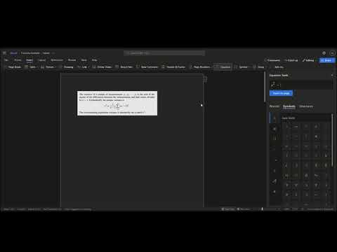](https://youtu.be/W_-FDNEpBrc)

https://www.youtube.com/watch?v=W_-FDNEpBrc